Code for the creation of the RDB Admission_Office

All the creation of it was made using SQLITE in the terminal.

1. Admission _Office table

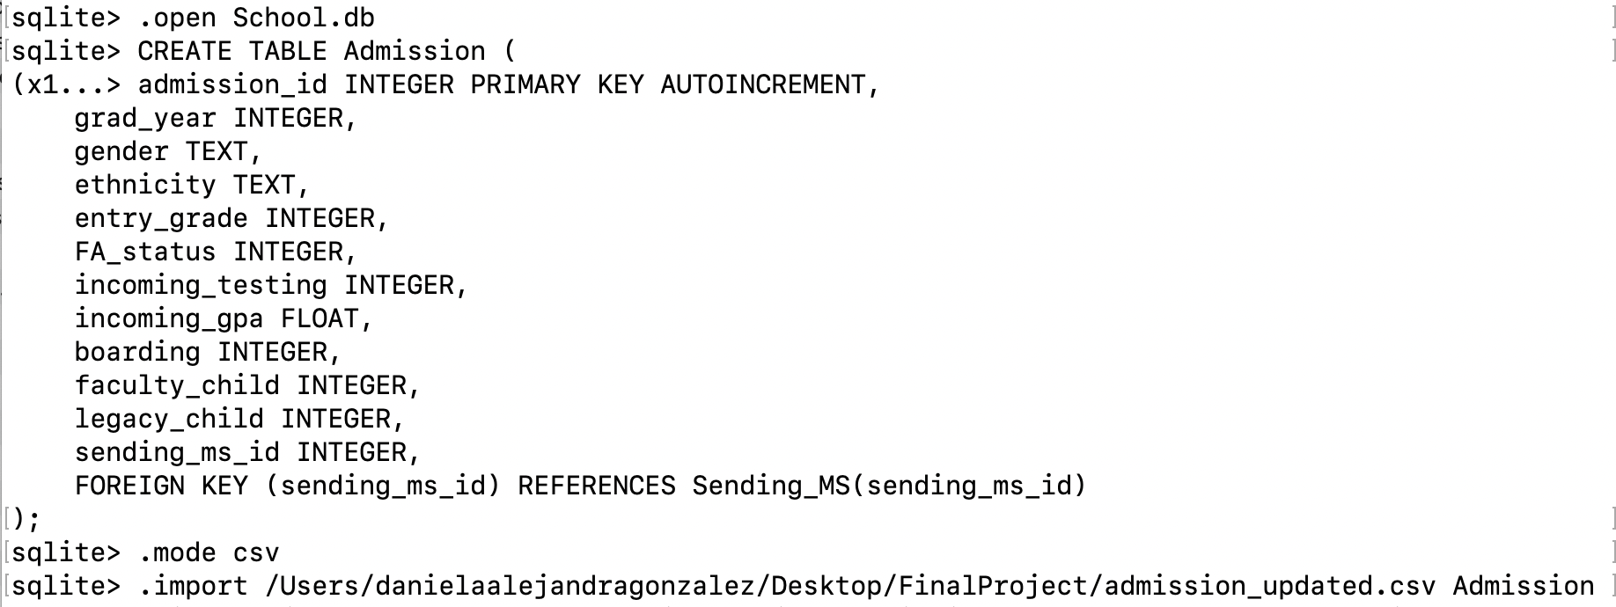,

sqlite> CREATE TABLE Admission_Office (

admission_id INTEGER PRIMARY KEY AUTOINCREMENT,

grad_year INTEGER,

gender TEXT,

ethnicity TEXT,

entry_grade INTEGER,

FA_status INTEGER,

incoming_testing INTEGER,

incoming_gpa REAL,

boarding INTEGER,

faculty_child INTEGER,

legacy_child INTEGER,

sending_ms_id INTEGER,

FOREIGN KEY (sending_ms_id) REFERENCES Sending_MS(sending_ms_id)

);

For this table I worked on the original Admission file and made some changes to the data type in the Booleans. I applied some one-encoding for the boarding, faculty_child, legacy_child, by replacing with 1 and 0:

admissions['boarding'] = admissions['boarding'].replace({True: 1, False: 0})

admissions['faculty_child'] = admissions['faculty_child'].replace({True: 1, False: 0})

admissions['legacy_child'] = admissions['legacy_child'].replace({True: 1, False: 0})

The table in the RDB was populated with data from the admission_updated.csv file .

1. Creation of the Sending_MS table

CREATE TABLE Sending_ms (

sending_ms_id INTEGER PRIMARY KEY AUTOINCREMENT,

ms_name TEXT,

ms_type TEXT

);

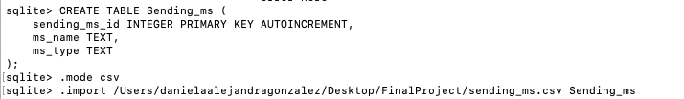

1. Universities table

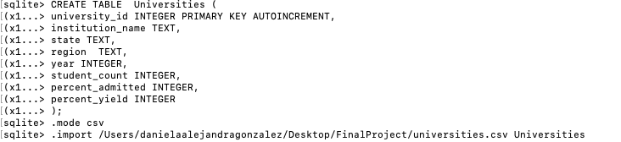

sqlite> CREATE TABLE Universities (

(x1...> university_id INTEGER PRIMARY KEY AUTOINCREMENT,

(x1...> institution_name TEXT,

(x1...> state TEXT,

(x1...> region TEXT,

(x1...> year INTEGER,

(x1...> student_count INTEGER,

(x1...> percent_admitted INTEGER,

(x1...> percent_yield INTEGER

(x1...> );

sqlite> .mode csv

sqlite> .import /Users/danielaalejandragonzalez/Desktop/FinalProject/universities.csv Universities

1. College table creation

For this one I replace the Booleans in the last three columns as well as replaced the nan values for sat and act with zero.  
data['sat']=data['sat'].replace(np.nan, 0)

data['act']=data['act'].replace(np.nan, 0)

data['hook_athlete']= data['hook_athlete'].replace({True: 1, False: 0})

data['hook_first_gen']= data['hook_first_gen'].replace({True: 1, False: 0})

data['hook_legacy']= data['hook_legacy'].replace({True: 1, False: 0})

I considered the float values as REAL in the table creation and saved the new file as updated_college:

sqlite> CREATE TABLE College (

(x1...> college_id INTEGER PRIMARY KEY AUTOINCREMENT,

(x1...> admission_id INTEGER,

(x1...> gpa REAL,

(x1...> sat REAL,

(x1...> act REAL,

(x1...> matric TEXT NOT NULL,

(x1...> university_id INTEGER,

(x1...> hook_athlete INTEGER,

(x1...> hook_first_gen INTEGER,

(x1...> hook_legacy INTEGER,

(x1...> FOREIGN KEY (admission_id) REFERENCES Admission(admission_id),

(x1...> FOREIGN KEY ( university_id) REFERENCES Universities(university_id)

(x1...> );

sqlite> .mode csv

sqlite> .import /Users/danielaalejandragonzalez/Desktop/FinalProject/college_updated.csv College

1. Students table

For the creation of this table there were not null values nor duplicated ones. The original file was used.

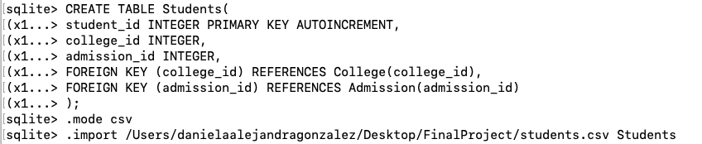

sqlite> CREATE TABLE Students(

(x1...> student_id INTEGER PRIMARY KEY AUTOINCREMENT,

(x1...> college_id INTEGER,

(x1...> admission_id INTEGER,

(x1...> FOREIGN KEY (college_id) REFERENCES College(college_id),

(x1...> FOREIGN KEY (admission_id) REFERENCES Admission(admission_id)

(x1...> );

sqlite> .mode csv

sqlite> .import /Users/danielaalejandragonzalez/Desktop/FinalProject/students.csv Students

1. Applications table

sqlite> CREATE TABLE Applications(

(x1...> application_id INTEGER PRIMARY KEY AUTOINCREMENT,

(x1...> student_id INTEGER,

(x1...> university_id INTEGER,

(x1...> admitted INTEGER,

(x1...> ed INTEGER,

(x1...> rd INTEGER,

(x1...> FOREIGN KEY (student_id) REFERENCES Students(student_id),

(x1...> FOREIGN KEY (university_id) REFERENCES University(university_id)

(x1...> );

sqlite> .mode csv

sqlite> .import /Users/danielaalejandragonzalez/Desktop/FinalProject/applications.csv Applications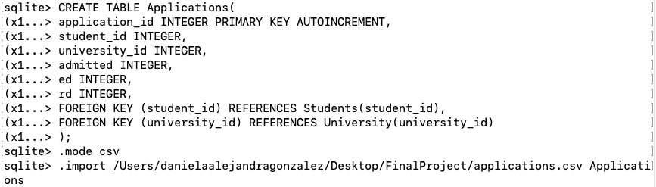

For this table no changes were made at the original file since no encoding was needed as well as no NaN values nor duplicated ones.